The Lapidarist Problem

noviembre 24

# Introduction

Some diamonds have been stolen. We have a huge dataset, containing characteristics and prices for 53930 of diamonds.

With the characteristics of the missing diamonds we want to estimate how much the stolen diamonds are worth.

# Objective

Know the value of diamonds with the following characteristics:

|  |  |  |  |  |  |  |  |  |  |
| --- | --- | --- | --- | --- | --- | --- | --- | --- | --- |
| **Cut** | **Color** | **Clarity** | **Depth** | **Table** | **x** | **y** | **z** | **latitude** | **longitude** |
| Good | I | VVS2 | 63.1 | 58 | 5.64 | 5.71 | 3.58 | 35.02636, | -114.3835 |
| Ideal | G | VS1 | 62.1 | 55 | 6.02 | 6.05 | 3.75 | 35.0035 | -109.7896 |
| Ideal | E | VS2 | 61.5 | 55 | 5.11 | 5.16 | 3.16 | 35.10544 | -106.6697 |
| Premium | J | VS1 | 61.6 | 59 | 4.67 | 4.71 | 2.89 | 34.9466 | -104.6473 |
| Premium | G | VS1 | 62.1 | 56 | 4.43 | 4.4 | 2.74 | 35.18864 | -101.986 |
| Good | F | SI2 | 63.3 | 57 | 6.08 | 6.14 | 3.87 | 35.26611 | -99.63874 |
| Ideal | D | VS1 | 60.9 | 57 | 5.2 | 5.17 | 3.16 | 35.51572 | -97.6708 |
| Ideal | G | VVS2 | 62.1 | 54.8 | 6.64 | 6.66 | 4.13 | 36.163605 | -95.7595 |
| Ideal | G | VVS2 | 62.4 | 56 | 4.72 | 4.74 | 2.95 | 37.689186 | -92.6473 |
| Premium | I | VS2 | 62.7 | 59 | 4.54 | 4.58 | 2.86 | 38.66303 | -90.21808 |

# What do we do?

First let's clean the data,removing some special characters and rows containing incomplete data.

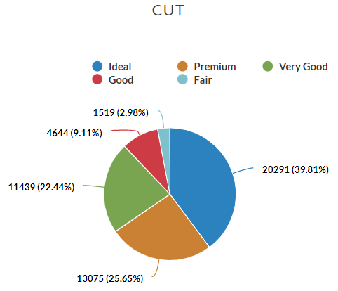

# Let's explore the data



Let's analyze some characteristics:

We have five different cuts with different counts

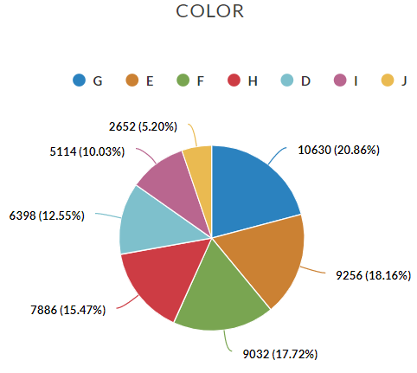

And we have seven different colors. The most popular is J.

CLARITY

 **SI1 ** **VS2 ** **SI2 ** **VS1 **

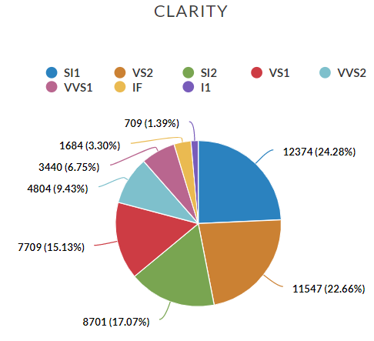

And we have eigth kinds of Clarity.

# Algorithm implementation

For this problem, I implemented the K-neighbors algorithm, considering eight neighbors and only some provided features.

I divided the data set into 70% training and 30% testing. The score on the test set had a precision of 0.83

# Calculating the cost of stolen diamonds

Implementing the algorithm with the characteristics provided, we obtain the following respective costs in the order at the beginning of the table:

3899.25

4688.375

1847.

1069.125

784.875

4451.

1782.75

6917.875

928.75

870.625